# Web Development Fundamentals

Web Development Fundamentals

Goals of this Unit

The goal of this unit is to introduce you to the field of front-end web development and create your first web page on the internet. You will learn the fundamentals of HTML and CSS, the languages essential to developing websites. You will also learn how to set up your local web development environment on your own computer.

After this unit, you will be able to:

Understand the architecture of the internet, at a high-level

Understand commonly used languages in Web Development

Understand what a front-end is

Understand how HTML is used for web development

Use HTML to build a structure for a website

Understand how CSS is used for web development

Use CSS to add initial styling to your website

Deploy a simple website using GitHub pages

Use Chrome DevTools

Learning is social. Whatever you’re working on, be sure to connect with the Codecademy community in the forums. Remember to check in with the community regularly, including for things like asking for code reviews on your project work and providing code reviews to others in the projects category, which can help to reinforce what you’ve learned.

Hello, Internet!

It is nearly impossible to overstate how much the internet has changed how we consume information and communicate with one another. More than four billion people around the world are internet users and the total number of websites on the world wide web is nearing two billion.

Despite the presence of the internet in our lives, very few internet users understand how it works. You don’t need to be an engineer to benefit from understanding how the internet works. However, understanding the internet’s infrastructure will help you decide if learning web development is right for you.

In this lesson, you will learn how the internet works behind the scenes. After finishing this lesson, you’ll be able to answer questions like:

* How is data sent from one computer to another?
* What is the relationship between a browser and a server?
* How is code turned into the experience that users see in their browsers?
* How has the web and web development changed from its invention to today?

By the end of this lesson, you will have the knowledge that you need to collaborate more effectively with engineers and jump into your own career in web development.

### Instructions

The Ever-Expanding Network

So how did the internet start? In 1969, the United States Department of Defense funded the creation of ARPANET, a precursor network to the internet. ARPANET stands for Advanced Research Projects Agency Network. ARPANET connected supercomputing centers run by government agencies and universities.

These institutions wanted to connect their individual networks for large-scale information transfer. However, many of them followed different standards and technical implementations. In the 1970s, the transmission control protocol and internet protocol, otherwise known as TCP/IP, were created to provide standards around the transfer of data that would allow these early networks to communicate with each other.

TCP/IP was researched and specified throughout the 1970s and adopted in the early 1980s. As different networks adopted TCP/IP, the interconnected global network of networks that is today known as the internet was formed.

### Instructions

Check out the map of early ARPANET supercomputers. When you’re ready, move to the next exercise.

### Community Forums

Still have questions? View this exercise's thread in the [Codecademy Forums](https://discuss.codecademy.com/t/372008).

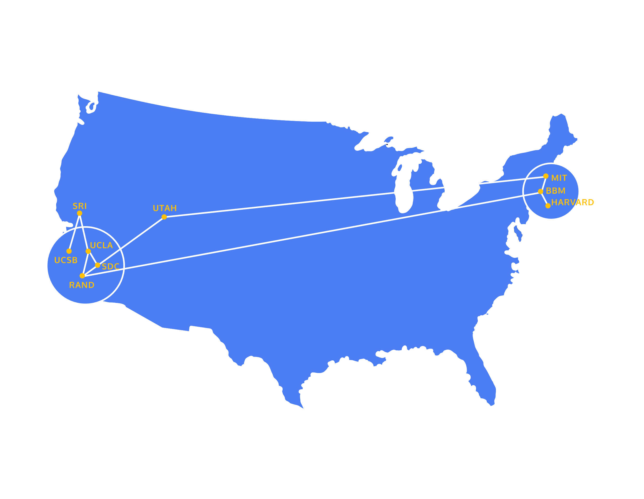

The World Wide Web

While people today often use the terms internet and world wide web interchangeably, they actually refer to quite different things.

The internet refers to the actual network of connected computing devices. Although the internet was around in the 1980s, there was not an intuitive way for most people to browse the internet. The internet just sent messages produced by one computer and presented them to another computer.

Engagement with the internet changed in 1989 when Tim Berners-Lee invented the world wide web. The world wide web is a collection of interlinked websites and other web resources. The world wide web, in combination with the rise of web browsers in the 1990s, introduced a user-friendly interface that enabled users to browse multimedia content and interact with other users.

The invention of the world wide web led to the use of the internet in wider society through the 1990s and the creation of a variety of websites that are still in use today.

### Instructions

The diagram to the right demonstrates how different pages on the World Wide Web are linked to one another. Move to the next exercise when you are ready to continue.

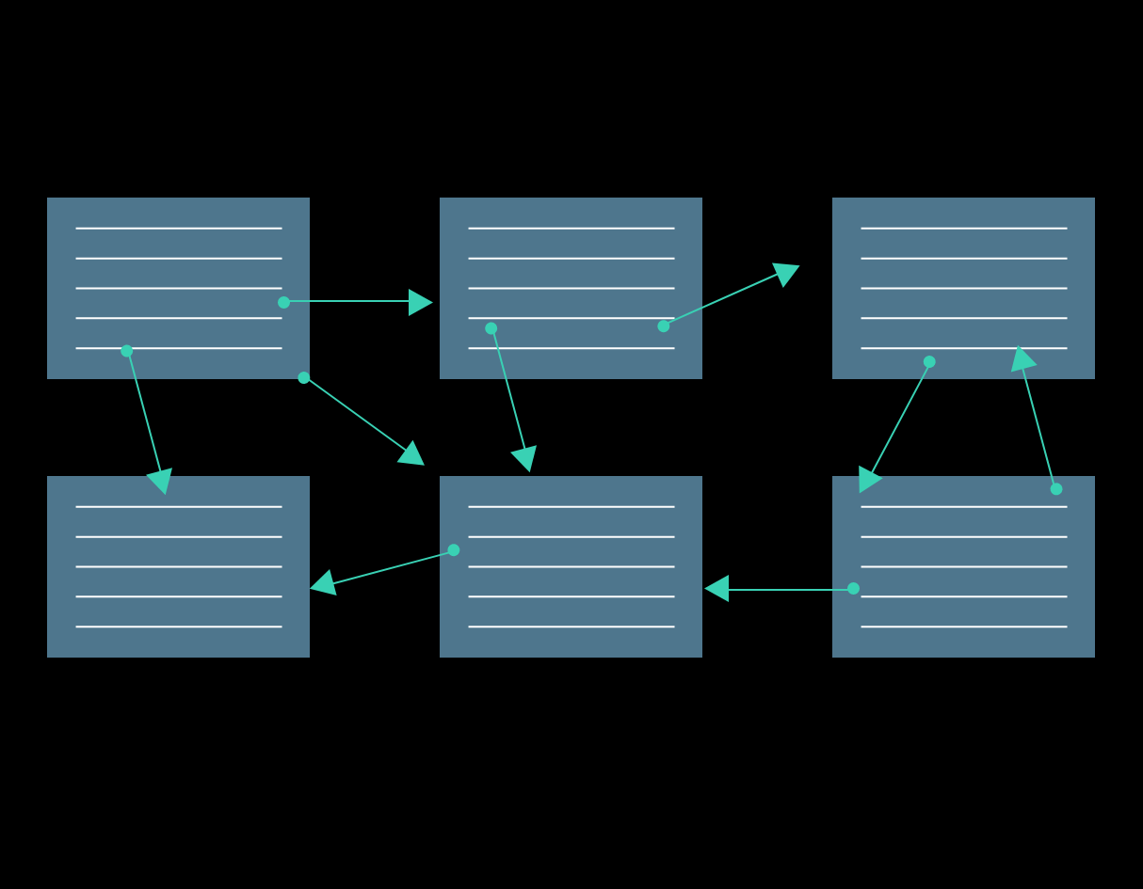

Browsers and Servers

As we’ve seen, the internet is a network that links computer devices worldwide, enabling people to share information with one another despite vast distances. But how is information sent from one device to another?

One way of understanding this process is to look at the *client-server* model. In this model, the *client* refers to the user’s device or program that is making a request for data. A client can be a browser or application running on a user’s laptop, smartphone, or tablet.

The *server* is the device or program in that network that waits for incoming requests and sends back data. This might be an in-house server, a rented server at a data center, or cloud server. At Codecademy, we have servers that store lesson data and our servers are sending this lesson data to your client device.

<https://content.codecademy.com/programs/code-foundations-path/web-dev-survey/servers-browsers-vII-audio-edited.mp4>

404 Status Code

Let’s take a deeper dive into the client-server model through exploring a part of HTTP that you’ve probably seen before: HTTP status codes.

When a server responds to a client, the server specifies a status code as a part of the response. Status codes indicate whether or not the HTTP request was successfully completed and if there was an error, they contain some information about the type of error that happened. The status code helps the browser know how to handle the data that was sent back with the response.

Review the HTTP statuses below and see if any of them seem familiar.

### Instructions

1. The browser is currently displaying a website that Alex has created to show photos and descriptions of her pets. If you click on the links for Dogs or Cats, you can see more information about Alex’s dogs and cats.
2. Next, click on the file icon in the upper left corner of the text editor. You’ll see the different HTML files that the server is ready to send to the browser whenever those links are clicked. These HTML files correspond to the different web pages that are displayed in the browser. When the Dogs link is clicked, the server will send the dogs.html file to the client.
3. Try out the Dogs and Cats links now!
4. Let’s create a 404 status response by making a request for a non-existent resource. Alex hasn’t built a webpage to list her turtles! Click on the link for Turtles to see the browser display the 404 status code.

<body>

  <img src='https://content.codecademy.com/programs/code-foundations-path/web-dev-survey/pets.jpg' width='400px'/>

  <p>Hi, I'm Alex. Welcome to my website dedicated to my pets! They are the cutest buckets of joy you'll ever lay your eyes on! Check them out here:</p>

  <ul>

    <li><a href="dogs.html">Dogs</a></li>

    <li><a href="cats.html">Cats</a></li>

    <li><a href="turtles.html">Turtles</a></li>

  </ul>

</body>

How Do Browsers Work?

So far we’ve seen how a single request and response are handled between a client and a server. But most of the time, our devices aren’t making a single request. Every time we load a webpage, our device sends a request for each file that makes up that page. So even when we’re just loading *one* webpage, that page can make multiple requests in order to retrieve different pieces of content, like images.

So how does this process work when we’re making multiple requests simultaneously?

All of the following steps happen in a split second:

1. When a user types in a URL and presses enter, the server processes the request and sends the HTML file back to the client. *HTML* files hold the content of a website and they also contain links for any additional assets or code that are needed to display the site properly.
2. The browser will begin to search for elements in the HTML file and it will start to make additional HTTP requests for any other external resources used by the HTML file. This often includes:

* One or more CSS stylesheets. *CSS* stands for cascading style sheets; CSS creates the style and layout of a web page. The browser will request the CSS stylesheet, and when the server sends it back, the browser analyzes the CSS and starts applying the visual styles to the content of the site.
* The request-response cycle also sends website assets, like images and videos, from the server to the browser. If these files are large, there might even be a noticeable delay before they are rendered by the browser.
* One or more JavaScript files. *JavaScript* makes the webpage interactive. This programming language functions as the “behavior” of the web page. A webpage that does not use JavaScript is known as a *static* webpage.

In most modern browsers, these additional requests are made in parallel. This means that these requests are initiated at the same time, and the browser does not wait to receive one resource before requesting the next resource.

All of the resources are typically displayed as soon as possible. The HTML will be displayed even if some of the other assets have not been received by the browser.

Voila! The user can now interact with the website that they requested to see. This whole process typically happens in about a second or less, depending on the speed of the user’s connection, the size of the website, and even the physical distance between the browser and the server.



Web 2.0

Now that we’ve covered some of the basics of how the internet works, let’s check out some trends that are fundamental to the emergence of modern web development and modern JavaScript.

The earliest static websites were composed of text, images, and links, with very little interactivity beyond browsing from one page to another. These websites are called static, which means lacking in movement because they do not change based on user behavior. As internet connection speeds and web technologies progressed, more complex interactions became possible on the web.

A collection of advances in the early 2000s created a cluster of web applications that are often called “Web 2.0”. In comparison to early static websites, Web 2.0 applications are often defined by:

* Providing a dynamic user experience by offering content that responds to user input without forcing the page to reload. In the early web, user input would typically take the user to a new page — and they would have to wait for the new page to load. In Web 2.0, websites could just update selected regions of the page, avoiding the interruption caused by reloading.
* Emphasizing user-generated content and social sharing. In the early web, content was generally authored by a single source. The rise of blogging, social media, and wikis in web 2.0 meant that users could generate content and share it with their friends.

There were important technical advances that enabled each of these advances in the user interface of the internet. For example:

* jQuery was the first JavaScript framework that could fetch data while the web page is running.
* The rise of web frameworks that connected to databases, like Spring, Django, and Ruby-on-Rails, enabled user-generated content to effectively be created, stored, and displayed.

### Instructions

What are the differences between Web 1.0 and Web 2.0 pages? The answers are in these screenshots.

On the left, the Web 1.0 page is static: it does not respond to user behavior and the content is the same for all users.

On the right, the Web 2.0 page is:

* Interactive — you can Like and Comment on the page
* Dynamic — the time since posting (currently “12 hrs”) updates without reloading the whole page
* Allows social interaction — a lot of friends liked this image!

Move to the next exercise when you’re ready to continue.

Current Internet Trends

The rise of internet-connected smartphones has profoundly changed how users interact with the internet. Mobile internet traffic now accounts for more than half of all internet traffic and web development practices have evolved in order to provide a good user experience regardless of device type.

#### Responsive Web Design

The rise of responsive web design has changed how websites are built. Responsive web design was enabled by additions to the CSS language, like media queries and relative units. These additions allow the presentation of websites to adjust based on the size of the window in which they are displayed.

#### Mobile Applications and Devices

The rise of internet-connected mobile applications has changed the way that we think about browsing the internet. Users accessing the internet on smartphones are likely to spend much more time with specific applications, rather than using their phone’s browser.

Though most mobile applications are internet connected, they are not part of the world wide web. The web is built out of links, whereas mobile applications are designed to keep the user’s attention.

If you want to learn about mobile development, web development is a great place to start! While the majority of mobile applications are built in programming languages, like Swift for iOS, it is increasingly common to see developers using JavaScript frameworks to build new apps.

Review

Congratulations! You should now have a general understanding of how the internet works, including:

* The growth of the internet as a network
* The difference between the internet and the world wide web
* The relationship between browsers and servers
* HTTP status codes, like 404 Not Found
* Big trends in web development, from static websites to Web 2.0 and the rise of mobile

If you work with engineers, this information will help you talk about websites and web applications at a more technical level. Or if you’re interested in becoming a web developer yourself, you now have the important context to start building your own website or web application

## What is the internet?

The internet is the world’s most popular computer network. It began as an academic research project in 1969, and became a global commercial network in the 1990s. Today it is used by more than 2 billion people around the world.

The internet is notable for its decentralization. No one owns the internet or controls who can connect to it. Instead, thousands of different organizations operate their own networks and negotiate voluntary interconnection agreements.

Most people access internet content using a web browser. Indeed, the web has become so popular that many people incorrectly treat the internet and the web as synonymous. But in reality, the web is just one of many internet applications. Other popular Internet applications include email and BitTorrent.

## Where is the internet?

The internet has three basic parts:

* **The last mile** is the part of the internet that connects homes and small businesses to the internet. Currently, [**about 60 percent**](http://www.leichtmanresearch.com/research/notes03_2015.pdf) of residential internet connections in the United States are provided by cable TV companies such as Comcast and Time Warner. Of the remaining 40 percent, a growing fraction use new fiber optic cables, most of which are part of Verizon’s FiOS program or AT&T’s U-Verse. Finally, a significant but shrinking number use outdated DSL service provided over telephone cables.

The last mile also includes the towers that allow people to access the internet with their cell phones. Wireless internet service accounts for a large and growing share of all internet usage.

* **Data centers** are rooms full of servers that store user data and host online apps and content. Some are owned by large companies such as Google and Facebook. Others are commercial facilities that provide service to many smaller websites. Data centers have very fast internet connections, allowing them to serve many users simultaneously. Data centers can be located anywhere in the world, but they are often located in remote areas where land and electricity are cheap. For example, [**Google**](http://www.datacenterknowledge.com/archives/2013/12/02/in-iowa-a-field-becomes-a-huge-google-server-farm/), [**Facebook**](http://www.wired.com/wiredenterprise/2013/11/facebook-iowa-wind/), and [**Microsoft**](http://www.wired.com/wiredenterprise/2013/06/microsoft-iowa-data-center/) have all constructed vast data centers in Iowa.
* **The backbone** consists of long-distance networks — mostly on fiber optic cables — that carry data between data centers and consumers. The backbone market is highly competitive. Backbone providers frequently connect their networks together at [**internet exchange points**](https://en.wikipedia.org/wiki/List_of_Internet_exchange_points_by_size), usually located in major cities. Establishing a presence at IEPs makes it much easier for backbone providers to improve their connections to others.

**[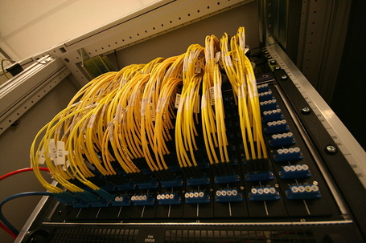](http://cdn1.vox-cdn.com/assets/4195719/1024px-AMS-IX_optical_patch_panel.jpg)**

Cables at an Internet Exchange Point. ([**Fabienne Serriere**](https://en.wikipedia.org/wiki/File:AMS-IX_optical_patch_panel.jpg))

## Who created the internet?

The internet began as [**ARPANET**](https://en.wikipedia.org/wiki/ARPANET), an academic research network that was funded by the military’s Advanced Research Projects Agency (ARPA, now DARPA). The project was led by [**Bob Taylor**](https://en.wikipedia.org/wiki/Robert_Taylor_(computer_scientist)), an ARPA administrator, and the network was built by the consulting firm of Bolt, Beranek and Newman. It began operations in 1969.

In 1973, software engineers **[Vint Cerf](https://en.wikipedia.org/wiki/Vint_Cerf)** and [**Bob Kahn**](https://en.wikipedia.org/wiki/Bob_Kahn) began work on the next generation of networking standards for the ARPANET. These standards, known as [**TCP/IP**](https://en.wikipedia.org/wiki/Internet_protocol_suite), became the foundation of the modern internet. ARPANET switched to using TCP/IP on January 1, 1983.

During the 1980s, funding for the internet shifted from the military to the [**National Science Foundation.**](http://www.nsf.gov/) The NSF funded the long-distance networks that served as the internet’s backbone from 1981 until 1994. In 1994, the Clinton Administration [**turned control**](http://www.nytimes.com/1994/10/24/business/us-begins-privatizing-internet-s-operations.html) over the internet backbone to the private sector. It has been privately operated and funded ever since.

## Did Al Gore invent the internet?

Former Vice President Al Gore is frequently quoted as claiming credit for the invention of the internet, but what he actually said in a [**1999 CNN interview**](https://www.youtube.com/watch?v=BnFJ8cHAlco) was “I took the initiative in creating the internet.” Gore was widely mocked for this statement. But the men who did invent the internet, TCP/IP designers Bob Kahn and Vint Cerf, [**wrote in Gore’s defense**](http://amsterdam.nettime.org/Lists-Archives/nettime-l-0009/msg00311.html) in 2000. They argue that Gore was “the first political leader to recognize the importance of the internet and to promote and support its development.”

“As far back as the 1970s Congressman Gore promoted the idea of high speedtelecommunications,” the pair wrote. “As a Senator in the 1980s Gore urged government agencies to consolidate what at the time were several dozen different and unconnected networks into an ‘Interagency Network.’” Gore sponsored the 1991 [**High Performance Computing and Communications Act**](https://en.wikipedia.org/wiki/High_Performance_Computing_Act_of_1991), which Kahn and Cerf say “became one of the major vehicles for the spread of the internet beyond the field of computer science.“

## Who runs the internet?

No one runs the internet. It’s organized as a decentralized network of networks. Thousands of companies, universities, governments, and other entities operate their own networks and exchange traffic with each other based on voluntary interconnection agreements.

The shared technical standards that make the internet work are managed by an organization called the [**Internet Engineering Task Force.**](http://www.ietf.org/) The IETF is an open organization; anyone is free to attend meetings, propose new standards, and recommend changes to existing standards. No one is required to adopt standards endorsed by the IETF, but the IETF’s consensus-based decision-making process helps to ensure that its recommendations are generally adopted by the internet community.

The [**Internet Corporation for Assigned Names and Numbers**](https://www.icann.org/) (ICANN) is sometimes described as being responsible for internet governance. As its name implies, ICANN is in charge of distributing domain names (like vox.com) and [**IP addresses**](http://www.vox.com/cards/the-internet/whats-an-ip-address). But ICANN doesn’t control who can connect to the internet or what kind of information can be sent over it.

## What’s an IP address?

Internet Protocol addresses are numbers that computers use to identify each other on the internet. For example, an IP address for vox.com is 216.146.46.10.

An ICANN department known as the [**Internet Assigned Numbers Authority**](https://www.iana.org/) is responsible for distributing IP addresses to ensure that two different organizations don’t use the same address.

## What is IPv6?

The current internet standard, known as IPv4, only allows for about 4 billion IP addresses. This was considered a very big number in the 1970s, but today, the supply of IPv4 addresses is nearly exhausted.

So internet engineers have developed a new standard called [**IPv6.**](https://en.wikipedia.org/wiki/IPv6) IPv6 allows for a mind-boggling number of unique addresses — the exact figure is [**39 digits long**](http://royal.pingdom.com/2009/05/26/the-number-of-possible-ipv6-addresses-read-out-loud/) — ensuring that the world will never again run out.

At first, the transition to IPv6 was slow. Technical work on the standard was completed in the 1990s, but the internet community faced a serious chicken-and-egg problem: as long as most people were using IPv4, there was little incentive for anyone to switch to IPv6.

But as IPv4 addresses became scarce, IPv6 adoption accelerated. The [**fraction of users who connected to Google via IPv6**](https://www.google.com/intl/en/ipv6/statistics.html) grew from 1 percent at the beginning of 2013 to 6 percent in mid-2015.

## How does wireless internet work?

In its early years, internet access was carried over physical cables. But more recently, wireless internet access has become increasingly common.

There are two basic types of wireless internet access: wifi and cellular. **[Wifi networks](https://en.wikipedia.org/wiki/Wi-Fi)** are relatively simple. Anyone can purchase wifi networking equipment in order to provide internet access in a home or business. Wifi networks use unlicensed spectrum: electromagnetic frequencies that are available for anyone to use without charge. To prevent neighbors’ networks from interfering with each other, there are strict limits on the power (and therefore the range) of wifi networks.

Cellular networks are more centralized. They work by breaking up the service territory into cells. In the densest areas, cells can be as small as a single city block; in rural areas a cell can be miles across. Each cell has a tower at its center providing services to devices there. When a device moves from one cell to another, the network automatically hands off the device from one tower to another, allowing the user to continue communicating without interruption.

Cells are too large to use the unlicensed, low-power spectrum used by wifi networks. Instead, cellular networks use spectrum licensed for their exclusive use. Because this spectrum is scarce, it is usually awarded by auction. Wireless auctions have [**generated tens of billions of dollars**](https://en.wikipedia.org/wiki/United_States_2008_wireless_spectrum_auction) in revenue for the US treasury since the first one was held in 1994.

## What is the cloud?

The cloud describes an approach to computing that has become popular in the early 2000s. By storing files on servers and delivering software over the internet, cloud computing provides users with a simpler, more reliable computing experience. Cloud computing allows consumers and businesses to treat computing as a utility, leaving the technical details to technology companies.

For example, in the 1990s, many people used Microsoft Office to edit documents and spreadsheets. They stored documents on their hard drives. And when a new version of Microsoft Office was released, customers had to purchase it and manually install it on their PCs.

In contrast, Google Docs is a cloud office suite. When a user visits docs.google.com, she automatically gets the latest version of Google Docs. Because her files are stored on Google’s servers, they’re available from any computer. Even better, she doesn’t have to worry about losing her files in a hard drive crash. (Microsoft now has its own cloud office suite called Office 365.)

There are many other examples. Gmail and Hotmail are cloud email services that have largely replaced desktop email clients such as Outlook. Dropbox is a cloud computing service that automatically synchronizes data between devices, saving people from having to carry files around on floppy disks. Apple’s iCloud automatically copies users’ music and other files from their desktop computer to their mobile devices, saving users the hassle of synchronizing via a USB connection.

Cloud computing is having a big impact for businesses too. In the 1990s, companies wanting to create a website needed to purchase and operate their own servers. But in 2006, Amazon.com launched Amazon Web Services, which allows customers to rent servers by the hour. That has lowered the barrier to entry for creating websites and made it much easier for sites to quickly expand capacity as they grow more popular.

## What is a packet?

A packet is the basic unit of information transmitted over the internet. Splitting information up into small, digestible pieces allows the network’s capacity to be used more efficiently.

A packet has two parts. The [**header**](https://en.wikipedia.org/wiki/IPv4#Header) contains information that helps the packet get to its destination, including the length of the packet, its source and destination, and a checksum value that helps the recipient detect if a packet was damaged in transit. After the header comes the actual data. A packet can contain up to 64 kilobytes of data, which is roughly 20 pages of plain text.

If internet routers experience congestion or other technical problems, they are allowed to deal with it by simply discarding packets. It’s the sending computer’s responsibility to detect that a packet didn’t reach its destination and send another copy. This approach might seem counterintuitive, but it simplifies the internet’s core infrastructure, leading to higher performance at lower cost.

## What is the World Wide Web?

The World Wide Web is a popular way to publish information on the internet. The web was created by [**Timothy Berners-Lee**](https://en.wikipedia.org/wiki/Tim_Berners-Lee), a computer programmer at the European scientific research organization [**CERN**](http://home.web.cern.ch/), in 1991. It offered a more powerful and user-friendly interface than other internet applications. The web supported hyperlinks, allowing users to browse from one document to another with a single click.

Over time, the web became increasingly sophisticated, supporting images, audio, video, and interactive content. In the mid-1990s, companies such as Yahoo and Amazon.com began building profitable businesses based on the web. In the 2000s, full-featured web-based applications such as Yahoo Maps and Google Docs were created.

In 1994, Berners-Lee created the [**World Wide Web Consortium**](http://www.w3.org/) (W3C) to be the web’s official standards organization. He is still the W3C’s director and continues to oversee the development of web standards. However, the web is an open platform, and the W3C can’t compel anyone to adopt its recommendations. In practice, the organizations with the most influence over the web are Microsoft, Google, Apple, and Mozilla, the companies that produce the leading web browsers. Any technologies adopted by these four become de facto web standards.

The web has become so popular that many people now regard it as synonymous with the internet itself. But technically, the web is just one of many internet applications. Other applications include email and BitTorrent.

## What’s a web browser?

A web browser is a computer program that allows users to download and view websites. Web browsers are available for desktop computers, tablets, and mobile phones.

The first widely used browser was [**Mosaic**](https://en.wikipedia.org/wiki/Mosaic_(web_browser)), created by researchers at the University of Illinois. The Mosaic team moved to California to found [**Netscape**](https://en.wikipedia.org/wiki/Netscape), which built the first commercially successful web browser in 1994.

Netscape’s popularity was soon eclipsed by Microsoft’s [**Internet Explorer**](https://click.linksynergy.com/deeplink?id=nOD/rLJHOac&mid=24542&u1=%5b%5dvx%5be%5d17840323%5br%5dcodecademy.com%5bt%5dw%5bd%5dD&murl=http://windows.microsoft.com/en-us/internet-explorer/download-ie), but an open source version of Netscape’s browser became the modern [**Firefox**](http://www.mozilla.org/en-US/firefox/new/) browser. Apple released its [**Safari**](https://go.redirectingat.com/?id=66960X1516588&xs=1&url=https://www.apple.com/safari/&referrer=vox.com&sref=https://www.vox.com/2014/6/16/18076282/the-internet&xcust=___vx__e_17840323__r_codecademy.com__t_w__d_D) browser in 2003, and Google released a browser called [**Chrome**](https://www.google.com/intl/en/chrome/browser/) in 2008. By 2015, Chrome had grown to be the [**most popular web browser**](https://en.wikipedia.org/wiki/Usage_share_of_web_browsers) with a market share around 50 percent. Internet Explorer, Firefox, and Safari also had significant market share.

## What is SSL?

SSL, short for Secure Sockets Layer, is a family of encryption technologies that allows web users to protect the privacy of information they transmit over the internet.

When you visit a secure website such as Gmail.com, you'll see a lock next to the URL, indicating that your communications with the site are encrypted. Here's what that looks like in Google's Chrome browser:

Screen_shot_2014-04-08_at_10

That lock is supposed to signal that third parties won't be able to read any information you send or receive. Under the hood, SSL accomplishes that by transforming your data into a coded message that only the recipient knows how to decipher. If a malicious party is listening to the conversation, it will only see a seemingly random string of characters, not the contents of your emails, Facebook posts, credit card numbers, or other private information.

SSL was introduced by Netscape in 1994. In its early years, it was only used on a few types of websites, such as online banking sites. By the early 2010s, Google, Yahoo, and Facebook all used SSL encryption for their websites and online services. More recently, there has been a movement toward making the use of SSL universal. In 2015, Mozilla announced that future versions of the Firefox browser would treat the lack of SSL encryption as a security flaw, as a way to encourage all websites to upgrade. Google is considering [**taking the same step**](https://www.chromium.org/Home/chromium-security/marking-http-as-non-secure) with Chrome.

## What is the Domain Name System?

The Domain Name System (DNS) is the reason you can access Vox by typing vox.com into your browser rather than a hard-to-remember numeric address such as 216.146.46.10.

The system is hierarchical. For example, the .com domain is administered by a company called Verisign. Verisign assigns sub-domains like google.com and vox.com. Owners of these second-level domains, in turn, can create sub-domains such as mail.google.com and maps.google.com.

Because popular websites use domain names to identify themselves to the public, the security of DNS has become an increasing concern. Criminals and government spies alike have sought to compromise DNS in order to impersonate popular websites such as facebook.com and gmail.com and intercept their private communications. A standard called [**DNSSEC**](https://en.wikipedia.org/wiki/Domain_Name_System_Security_Extensions) seeks to beef up DNS security with encryption, but few people have adopted it.

## Who decides what domain names exist and who gets them?

The domain name system is administered by the [**Internet Corporation for Assigned Names and Numbers**](https://www.icann.org/) (ICANN), a non-profit organization based in California. ICANN was founded in 1998. It was granted authority over DNS by the US Commerce Department, though it has increasingly asserted its independence from the US government.

There are two types of domain names. The first is generic top-level domains (gTLDs) such as .com, .edu, .org, and .gov. Because the internet originated in the United States, these domains tend to be most popular there. Authority over these domains is usually delegated to private organizations.

There are also country-code top-level domains (ccTLDs). Each country in the world has its own 2-letter code. For example, the ccTLD for the United States is .us, Great Britain’s is .uk, and China’s is .cn. These domains are administered by authorities in each country. Some ccTLDs, such as .tv (for the island nation of Tuvalu) and .io (the British Indian Ocean Territory), have become popular for use outside of their home countries.

In 2011, ICANN [**voted**](http://arstechnica.com/business/2011/06/icann-approves-plan-to-vastly-expand-top-level-domains/) to make it easier to create new gTLDs. As a result, there may be dozens or even hundreds of new domains in the next few years.

[**Support Vox's explanatory journalism**](https://www.vox.com/pages/support-now)

Every day at Vox, we aim to answer your most important questions and provide you, and our audience around the world, with information that empowers you through understanding. Vox’s work is reaching more people than ever, but our distinctive brand of explanatory journalism takes resources. Your financial contribution will not constitute a donation, but it will enable our staff to continue to offer free articles, videos, and podcasts to all who need them. Please consider making a contribution to Vox today, [**from as little as $3.**](https://www.vox.com/pages/support-now)